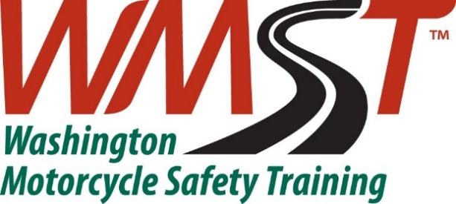

Monroe Site Procedures Checklist
Pre-Range Session Procedures Checklist

- Unlock porta potty and set out hand washing station
- Ensure range cart is ready and, on the range,
  - Water topped off
  - First Aid kit
  - Fire Extinguisher
  - Kitty litter

- Ensure all bikes are started and ridden before class starts.
- Set up the range before the class arrives.
- If your classroom session was conducted online or is range first, collect registrations, waivers and check ID before you begin.
- Ensure containers are closed and locked prior to classes starting
- Confirm that all class paperwork is ready, including crash reports and evaluation forms.
Post-Range Session Procedures Checklist
- Ensure the range is picked up and put all range equipment back in the correct storage areas in an orderly fashion.
- Store motorcycles that require maintenance close to the door so that they are easily accessible. Fasten a RED TAG noting the issue to the handlebar where it is visible, i.e. Will not start, Flat tire, Stalling.
- Top off all motorcycles with gas that were ridden
- Record repair needs on the Damage Report and include it in your class pack and class report.
- Take trash to the trash receptacle for removal.
- Use the scanner at your location to scan and send class packs to instructor@gowmst.com. Store scanned class packs in the locked filing cabinet. Everett class packs can be dropped off in the main office locked cabinet or with admin during business hours.
- Lock porta potty and place hand washing station in with range cart.
- Be sure all containers are locked. Be sure the access gate is locked exactly like the picture. No exceptions.

